Week 4
August 10, 2026 (Monday)
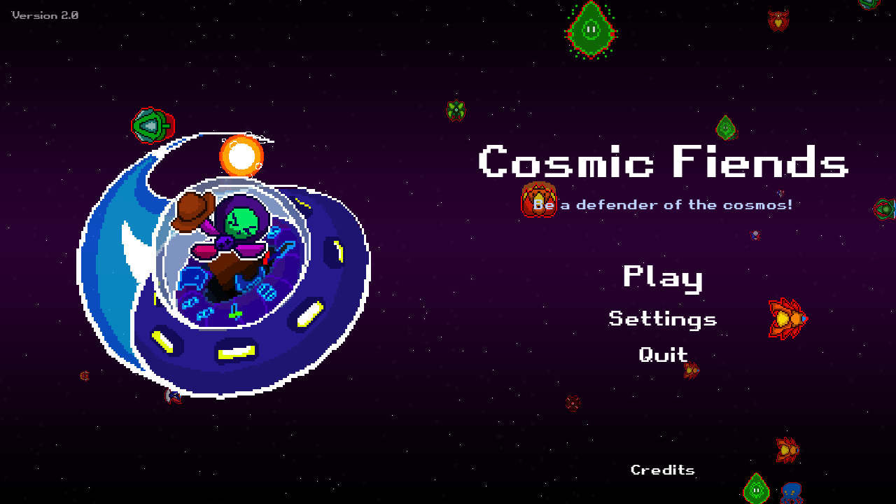
Caption / Description:
Main menu rebuild, environment spawner, and inventory fixes
Activity / Output:
Built the main menu in Godot with a parallax background and drifting enemy sprites, tuned entirely from the editor (UFO landing transform, sprite frames, credits text, spawn rates and enemy rosters). Added occasional boss and player ship flybys, a Quit button, scrollable credits, a Return to Main Menu option in the pause menu, and a mute button beside pause on both HUDs. Reworked the environment spawner into three Space Decor layers so asteroids, shrines, trash, and scrap stop overlapping, wired trash and chests to pay out currency and gems by rarity, redid the inventory into a two column layout, and fixed three bugs: the weapon firing extra rounds at random, the pierce weapon dashing into asteroid geometry, and the ship and enemies getting stuck once inside it.

August 11, 2026 (Tuesday)
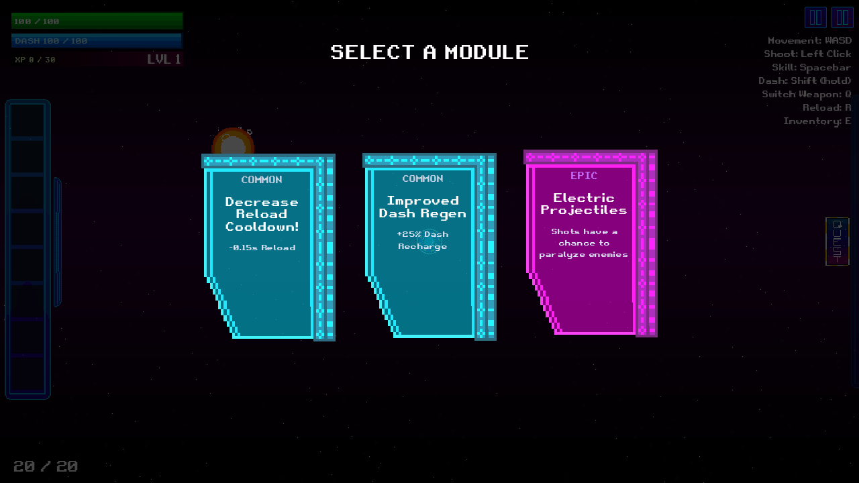
Caption / Description:
Fixing accidental module picks and finishing the Cosmic Hub
Activity / Output:
Fixed the module picking screen so a card can no longer be chosen by accident, a short cooldown timer on the pick panel itself now has to run out before card clicks are accepted. Finalised the early access version of the Cosmic Hub so it reads as a finished area instead of a test space, and went back over Day 1's work, adjusting the main menu's title treatment and item spacing and revisiting the environment decoration layers and the inventory readouts.

August 12, 2026 (Wednesday)
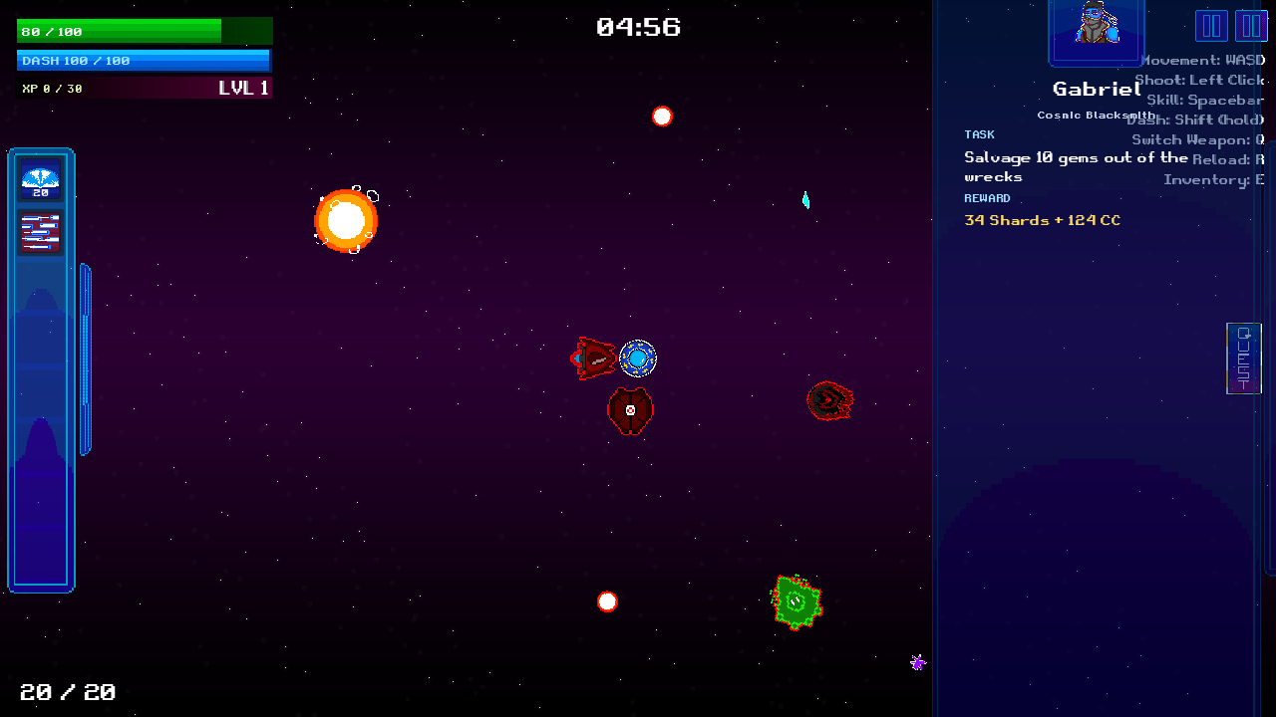
Caption / Description:
First draft of the contract system, NPCs calling in side jobs
Activity / Output:
Drafted a new mid run contract system where hub staff call Toby during a mission with side jobs he can accept or decline. Built the incoming call panel (portrait, role, task, reward, Accept and Decline) and a separate scrollable contracts list opened with the Tab key. Wrote a five character caller roster, each with their own lane of work, drafted randomized tasks and rewards, and set it up so accepting pushes the next call further out while declining brings it sooner. Also drafted the escort and delivery jobs as their own editable scenes (cargo roped to the ship, towed to a citadel with a pointing arrow), kept finished contracts in the list instead of removing them, and wrote real dialogue for Mary Jane, Cody, and Lorraine.

August 13, 2026 (Thursday)
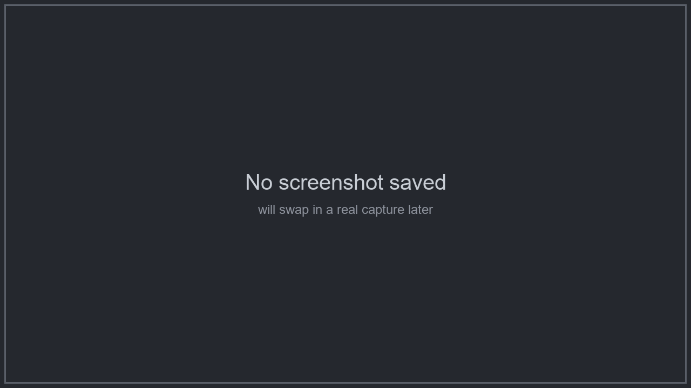
Caption / Description:
Polishing the contract panels and closing out a pile of bugs
Activity / Output:
Reworked both contract panels onto a plain Control node so they sit inside the player HUD, reskinned them with the game's own pixel art interface frame, added a padding container, and put a clickable tab button on the contracts panel. Moved the caller portrait into its own framed row, brought the first call forward to thirty seconds with a visible countdown and auto decline, and fixed callers repeating too often by dealing them from a shuffled bag. Tuned the FlaschBourn boss's shots, shortened the escort rope, and fixed two real bugs: a burst skill that lost its remaining shots if the game was paused mid use, and a contract panel that had grown so tall its own Accept and Decline buttons were pushed off the bottom of the screen.

August 14, 2026 (Friday)

Caption / Description:
The Citadel stage, real bug fixes, and a new Objectives panel
Activity / Output:
Added the actual Citadel stage, the everything at once level with every enemy type in it, reachable by clicking the citadel building in the level select screen. Fixed the background so it shows the correct sun for whichever system was picked, and finally got the Restart button replaying the exact stage, difficulty, and mode instead of always dropping into a flat five minute test run. Retired the old test_area scene for a proper battle_area copy, swapped the sidebar's placeholder icons for the real cooldown art, gave Force Field and Super Shield their own scenes, and fixed the Shrink Device module only shrinking how the ship looked and not its hitbox. Also fixed the shockwave module (it wasn't visible, and its stun range was too big) and the contracts tab getting cut off screen, then added NPC voice clips, hub sprinting, and a new Objectives panel.

